1. Installation

Install the uploaded zip file of the program. If you’re reading this it can be assumed you have already done so and have the program downloaded.

1. Opening the project

In order to open the project you must have netbeans downloaded. You can download the latest version of Netbeans from the website([https://netbeans.apache.org](https://netbeans.apache.org/)). Once you have netbeans downloaded, run Netbeans. Once it has opened click on the button ‘file’ in the top left corner. This will open up more button options, from here go down to import project, and click the ‘from zip’ option that shows up. From here select the zipped file of the program.

1. Running the project

Now that you have the project imported, it should show up on your sidebar on the left called ‘projects’. From there look for the project “4.1.2_Wang_FinalProject, click on the folder, then click source packages, then default packages, and then finally double click on the file ‘Board.java’. Now that you have the main class selected, click the green run project button at the top of the screen or click f6. Congrats the game is now running.

1. How to play the game

Instructions on the specific rules of the game can be read on the intro screen and on the main game board. In order to play, click on the play button of the main game. Now you must choose a pin to start with empty. Do this by clicking any circle. Now in order to move a circle, first click on the circle you would like to move, and then click on the circle you would like to move to. Continue making moves until the game gives you a game over screen. You can then observe your score and click continue to see the all time leaderboard of the game.

1. Special features

On the game screen, it lists how the scoring of the game works. There are multiple ‘endings’ or objectives that the user can complete to get more points. Moreover, the game has an intro screen, along with a gameover, and leaderboard screen. As mentioned above, as the game finishes you will be shown a gameover screen with your score. Furthermore, the leaderboard displays the top 10 users with the most total points. You can click on the button ‘Sort by Highest Score’, to sort by the users based on their highest score in one run.

1. Images of the game

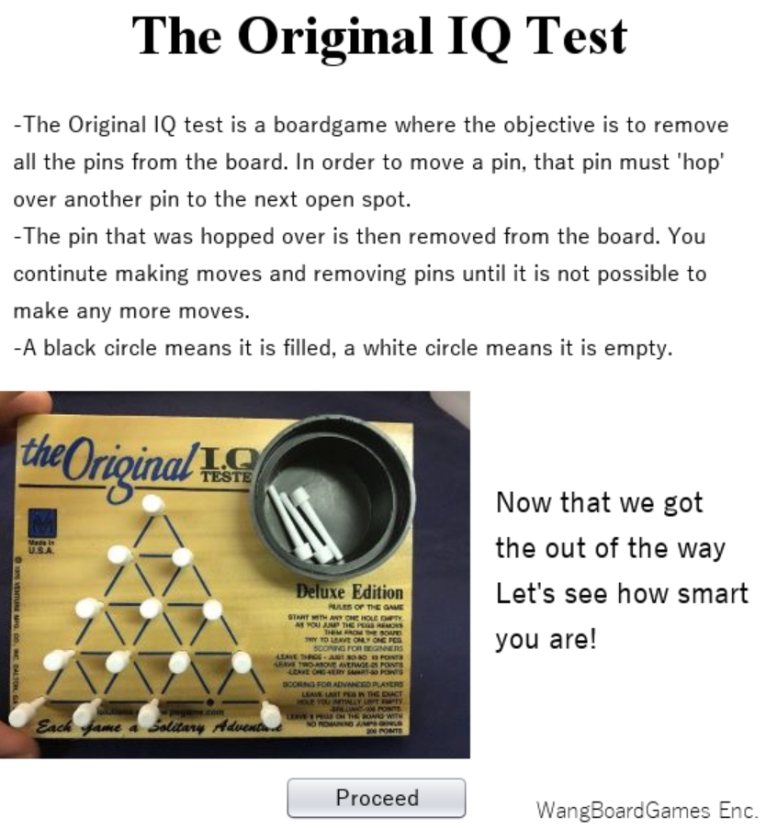

This is the intro screen

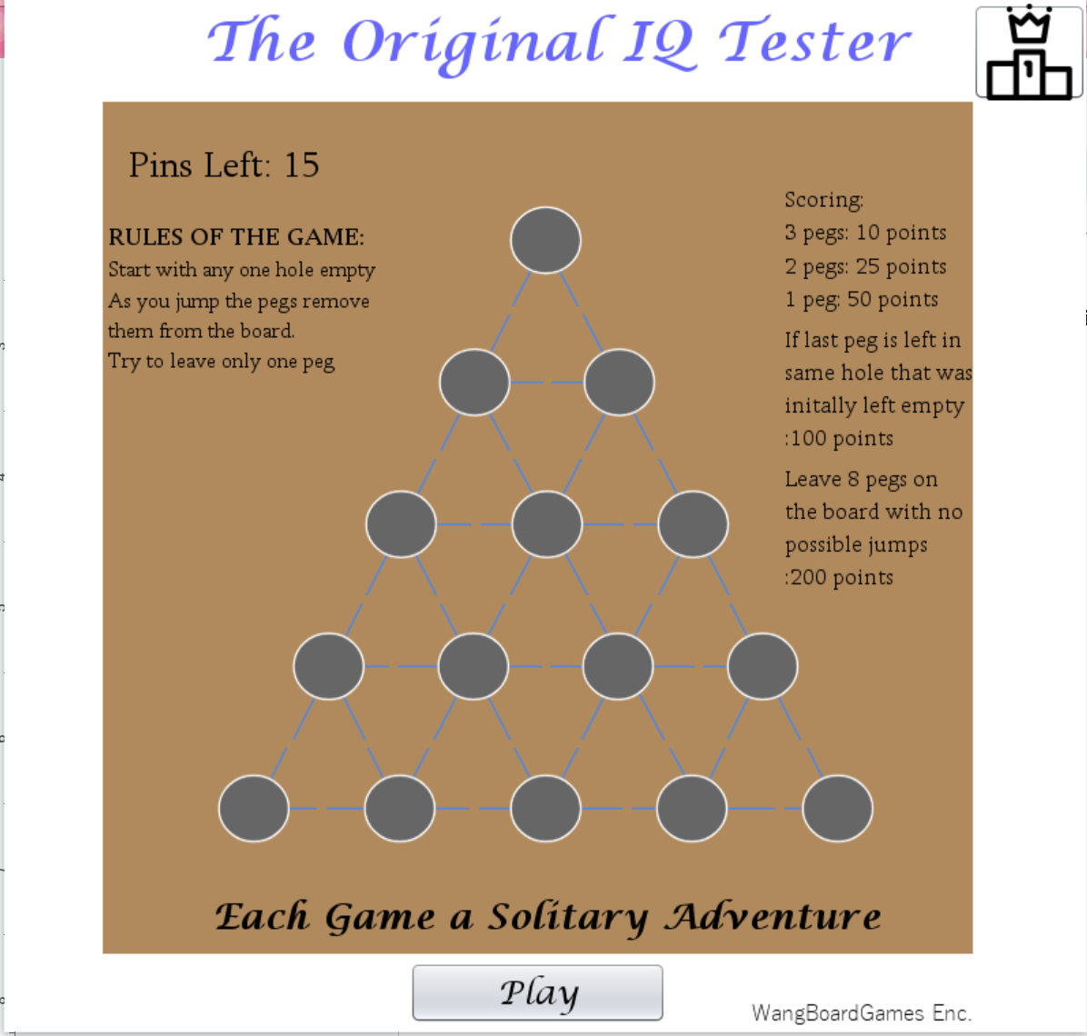

This is the game screen

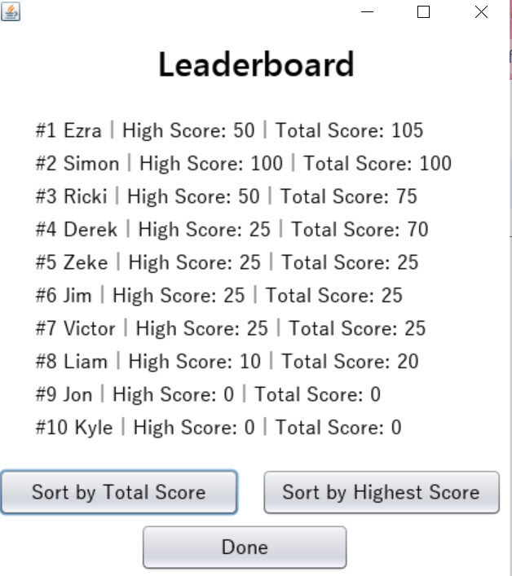

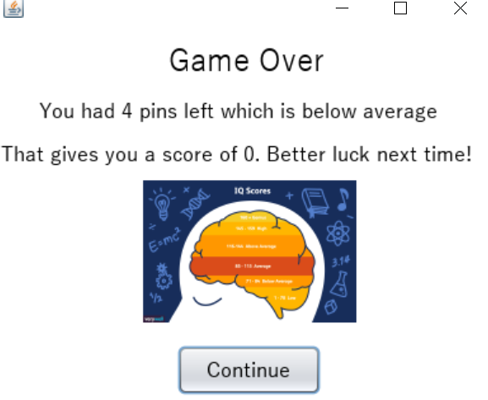

Finally above is the game over screen, along with the leaderboard screen.